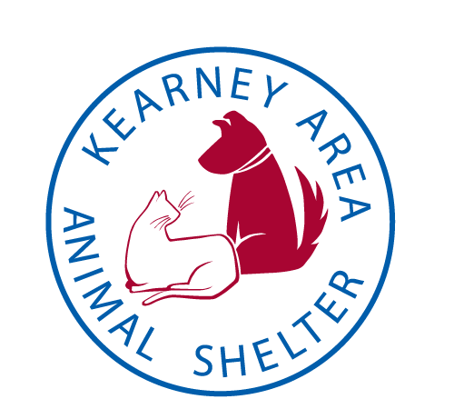
Kearney Area Veterinary Clinics

Hilltop Pet Clinic
(308) 236-5912
4507 1st Avenue Place Kearney, NE
West Villa Animal Hospital
(308) 234-9911
2518 W 24th Street Kearney, NE

Cottonwood Veterinary Clinic
(308) 234-8118
5912 2nd Avenue Kearney, NE

Riverside Animal Hospital
(308) 234-2617
322 Central Avenue Kearney, NE

Northgate Veterinary Clinic
(308) 234-9512
404 E 56th Street Kearney, NE

